# EX.NO:11C DATE:

**REMOTE PROCEDURE CALL FOR LIST OPERATIONS- XMLRPC**

# AIM:

To Implement an XML RPC code for the following functions,

1. No items in a list
2. Smallest element in a list
3. Largest element in the list
4. Converting a list to a set.

# PROGRAM

**Server Side:**

from xmlrpc.server import SimpleXMLRPCServer def list_length(a):

return len(a)

def list_maximum(a):

return max(a)

def list_minimum(a):

return min(a) def list_to_set(a):

f=list(set(a)) return f

def list_concate(a,b):

return a+b

server = SimpleXMLRPCServer(("localhost", 8000)) print("Listening on port 8000...") server.register_function(list_length,"list_length") server.register_function(list_maximum, "list_maximum") server.register_function(list_minimum, "list_minimum") server.register_function(list_to_set, "list_to_set") server.register_function(list_concate, "list_concate") server.serve_forever()

# Client Side:

import xmlrpc.client

proxy= xmlrpc.client.ServerProxy('http://localhost:8000/') while True:

print("PRESS 1-->STRAT || 2--> STOP ") c=int(input("ENTER YOUR CHOICE")) a=[]

b=[]

if c==1:

print("ENTER THE ELEMENTS TO ADD FIRST LIST") print("PRESS -1 TO EXIT THIS LIST")

while True:

d=int(input("--->")) if d==-1:

break a.append(d)

print("ENTER THE ELEMENTS TO ADD SECOND LIST") print("PRESS -2 TO EXIT THIS LIST")

while True:

e=int(input("--->")) if e==-2:

break b.append(e) if c==2:

break print(a) print(b)

print("list_length",proxy.list_length(a)) print("list_maximum",proxy.list_maximum(a)) print("list_minimum",proxy.list_minimum(a)) print("list_to_set",proxy.list_to_set(a)) print("list_concate",proxy.list_concate(a,b))

# OUTPUT

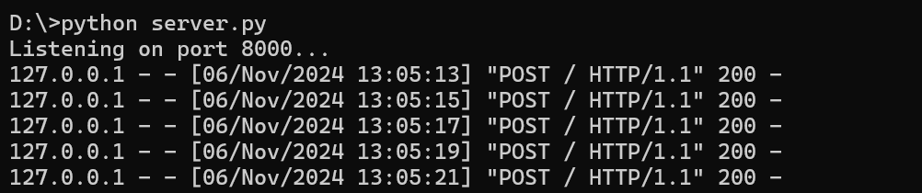

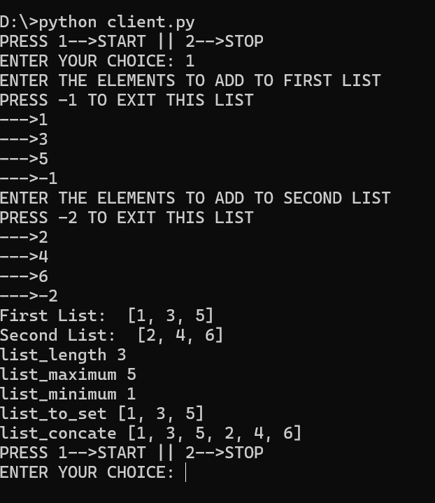

**RESULT**

Hence the following list of operations have been Implemented by an XML RPC code for the following functions

1. No of items in a list
2. Smallest element in a list
3. Largest element in the list
4. Converting a list to a set.